Student Advising Webpage

Overall Challenges/Reflection:

* The majority of challenges I had when creating the webpage, after I had gone through the process of making a mockup design for the overall site, was getting back into using html and css. Luckily I have had experience using html5 and css prior to the project so coding up the process wasn’t say an entirely new thing that I needed to learn.

* The php portion of the coding did not actually seem quite challenging for me. If I didn’t know how to do something, I would go on google and research for about an hour and eventually stumble upon a ways of how to do things in sometimes more easier ways than I would have originally prepared myself to face.

Pages:

* Log In page:

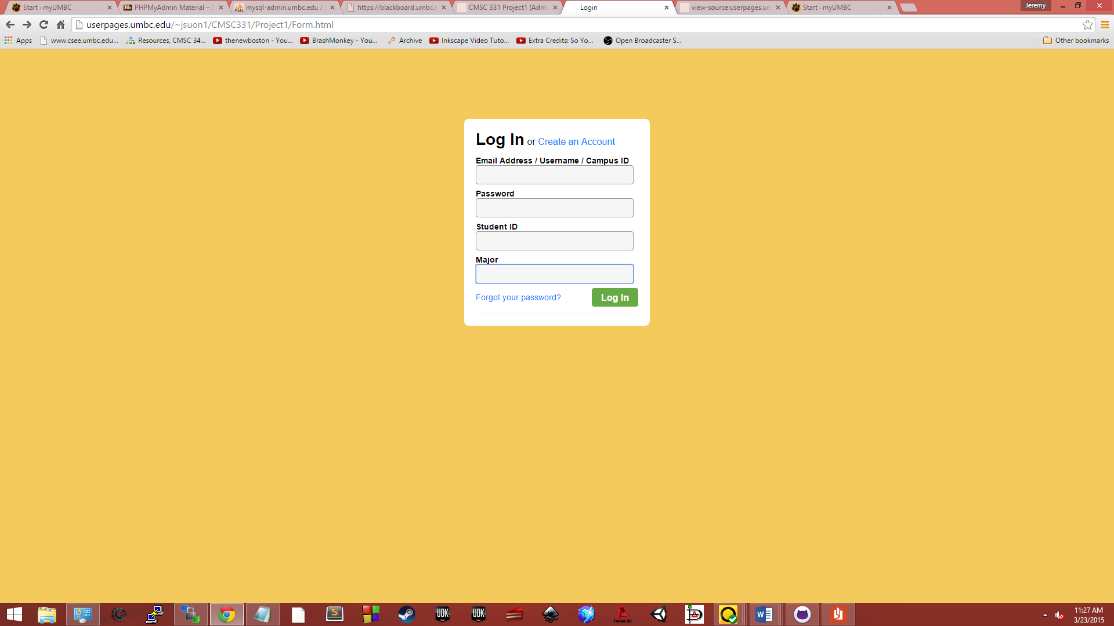

* + The Log In page was, as you can normally would see, is based off of the UMBC Login page. When looking for ideas, and this idea came later in seconds, I went to login my.umbc.edu and found that the login page would be greatly fitting for a student login page in the case if they wanted to schedule for an appointment. I looked at the UMBC code for the webpage and continued to base my code off of what I saw.
* Advising Selection

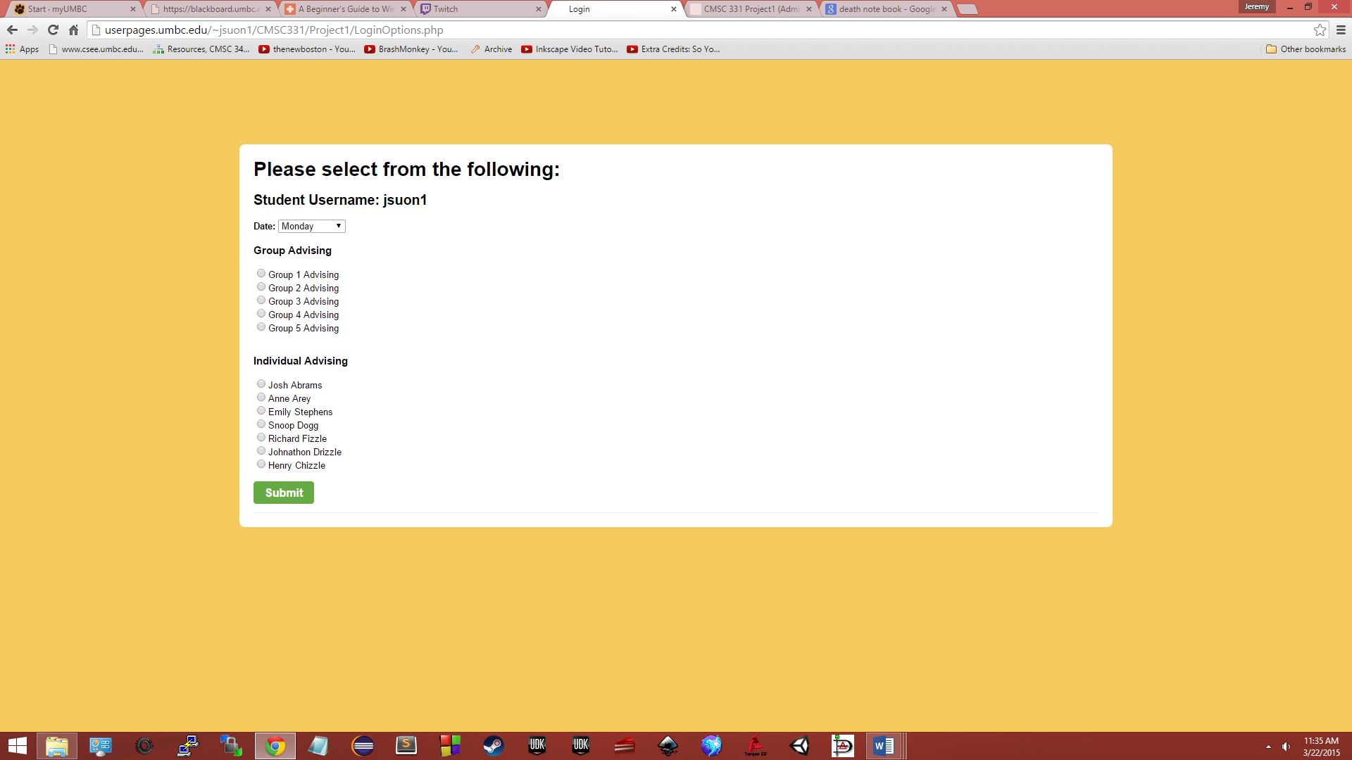

* + Again, based off the code for the original login page, it would 1) be fitting for all the continuing pages after the login page to have the same color scheme and theme, that being the basis of a white box in the middle of the screen stating the content surrounded by a sand-colored background. And 2) Provide as a nice aesthetic for any students to look at while going through the process. The page

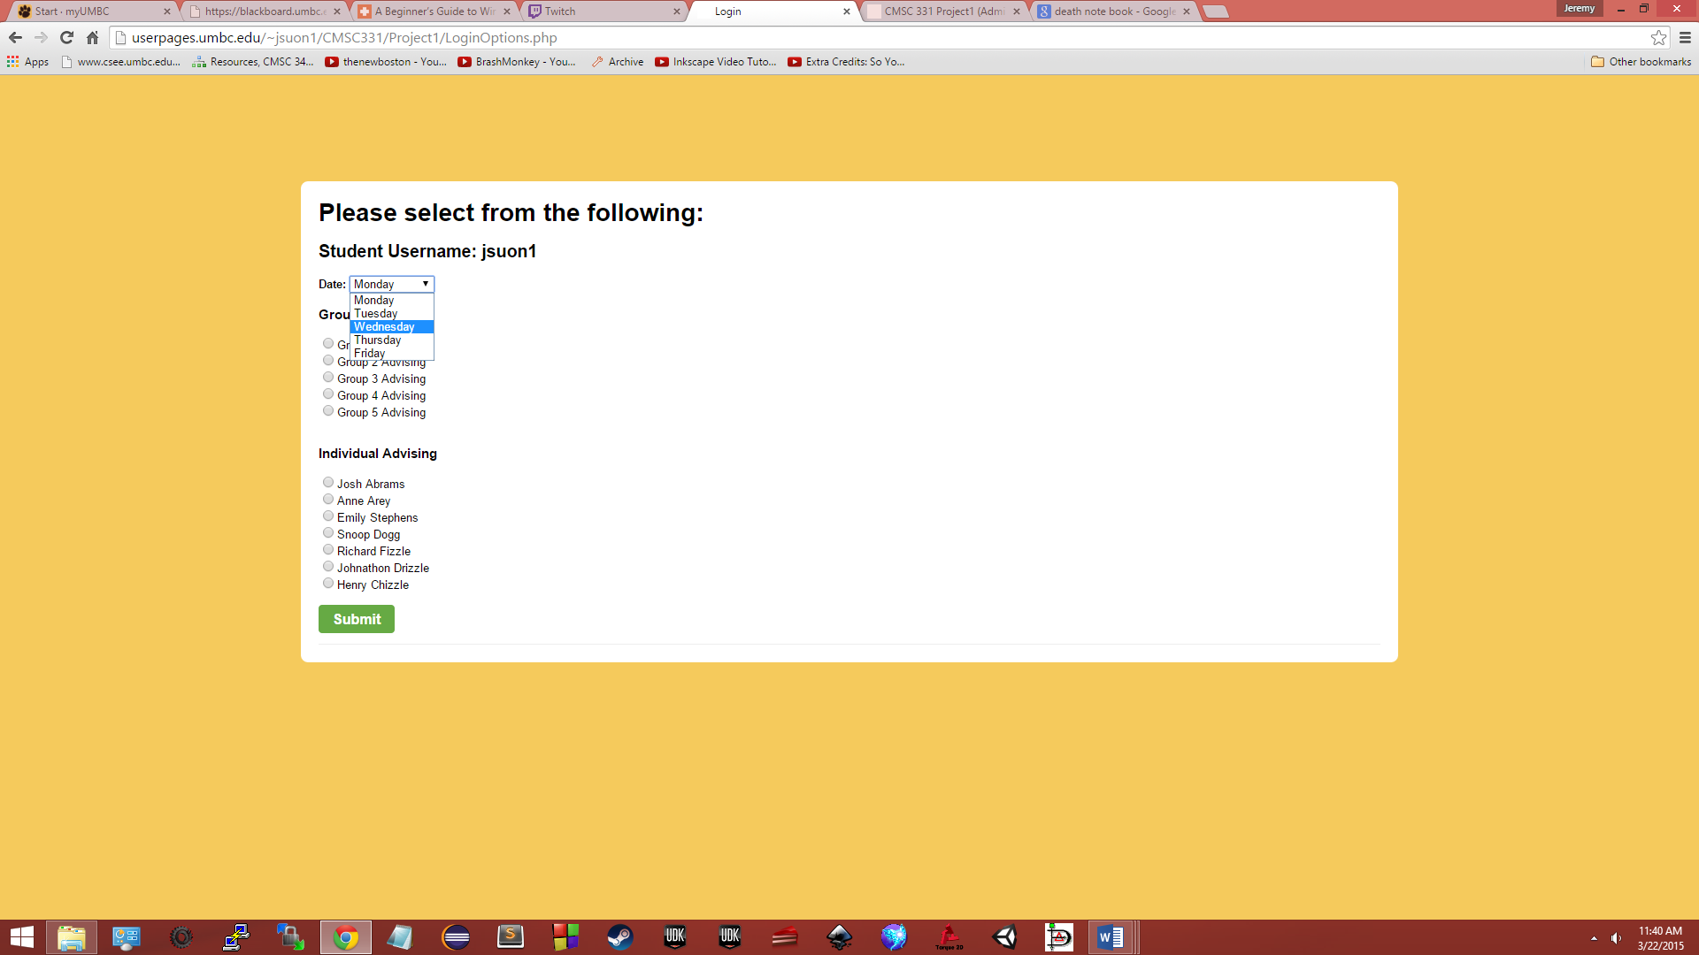 itself contains three pieces of information that the student is able to see and analyze. The first being the student’s username posted at the top. This allows the student to confirm that this would be the username that would be assigned to the appointment the student selects. The next would be the date. Followed by a drop down menu, the student will be able to select a date (for simplicity, dates would be listed as Monday, Tuesday, etc., in real-world application those dates would be replaced with actual appointment dates with the format mm-dd-yy). The last piece of information is a selection for the student to decide what type of appointment and which selection would he want, selections being which group he would want to be in for a group advising appointment, or which advisor he would like to meet for an individual advising appointment.

* Timeslots for the appointments

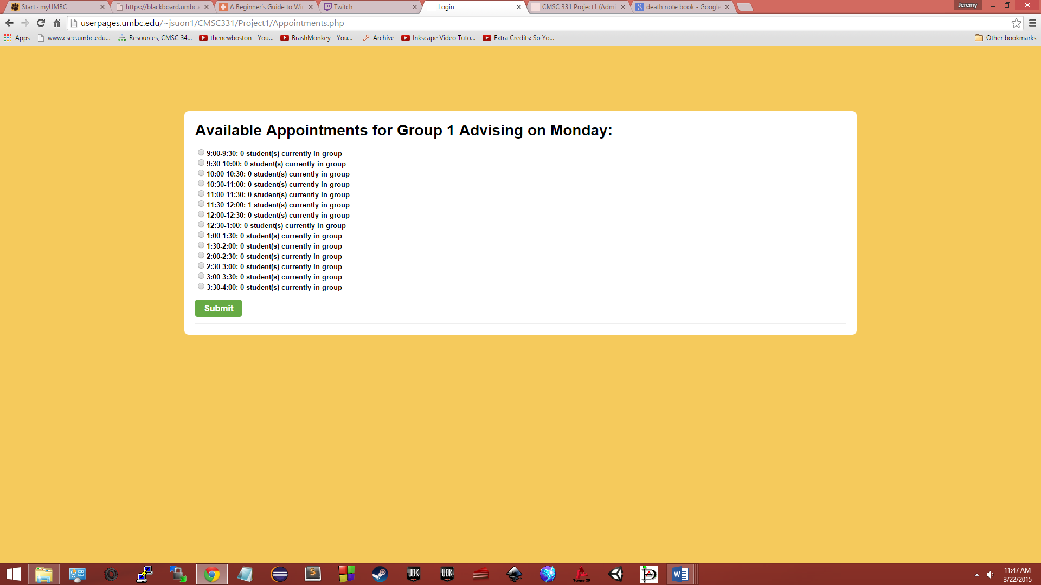

* + If the student chose for a group advising appointment, he/she would be prompted with all the available dates for the group meets followed by how many students are already within the current group.

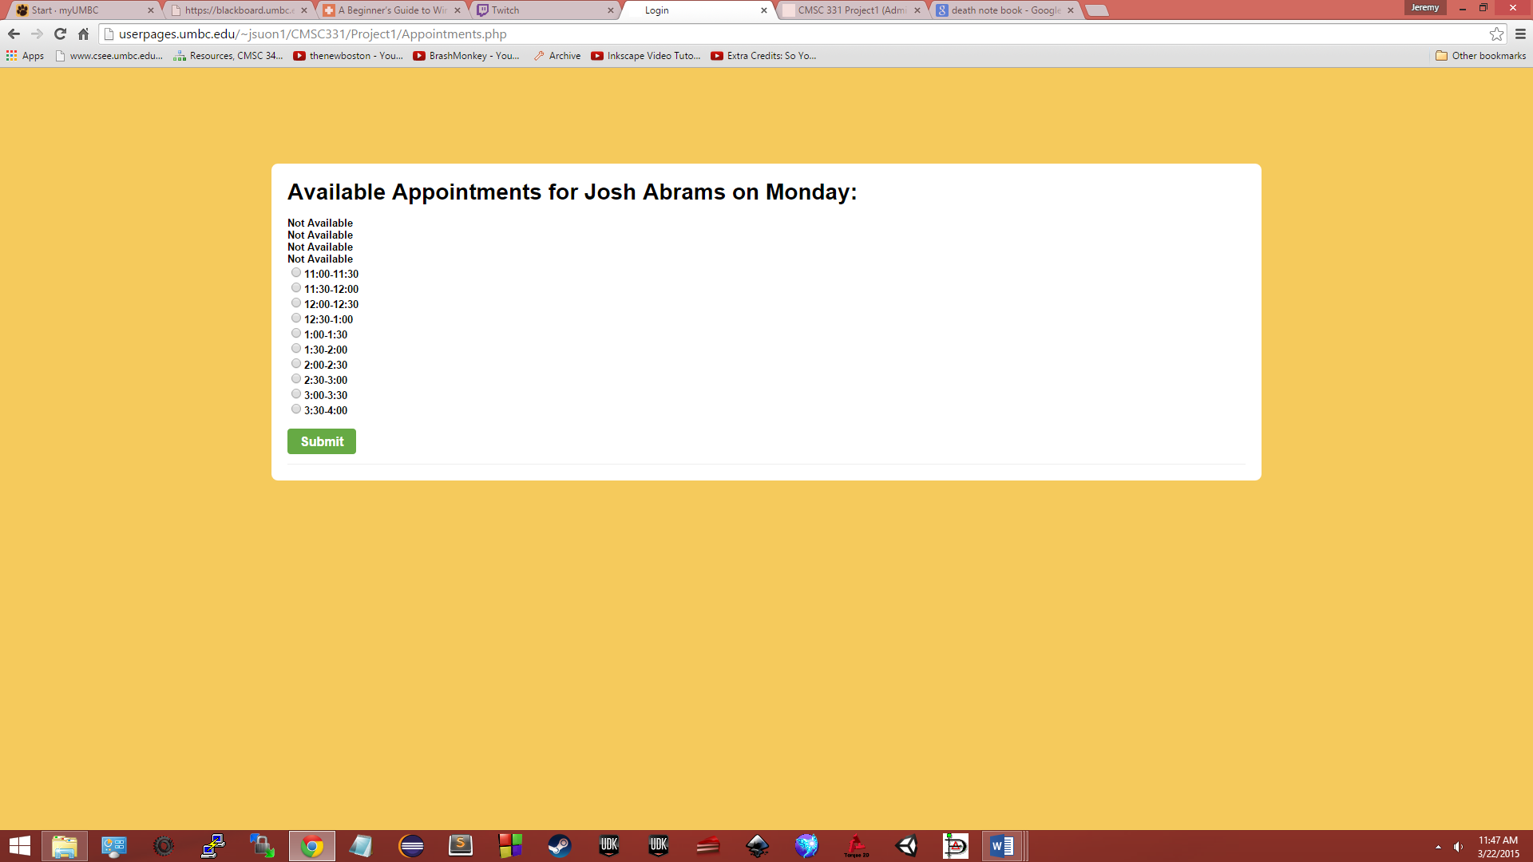

* + If the student were to choose an individual advising appointment, he/she would be prompted with the available dates alone or if a date has been occupied or is not able to be scheduled, the date would simply read out as Not Available.
* Affirmation screen

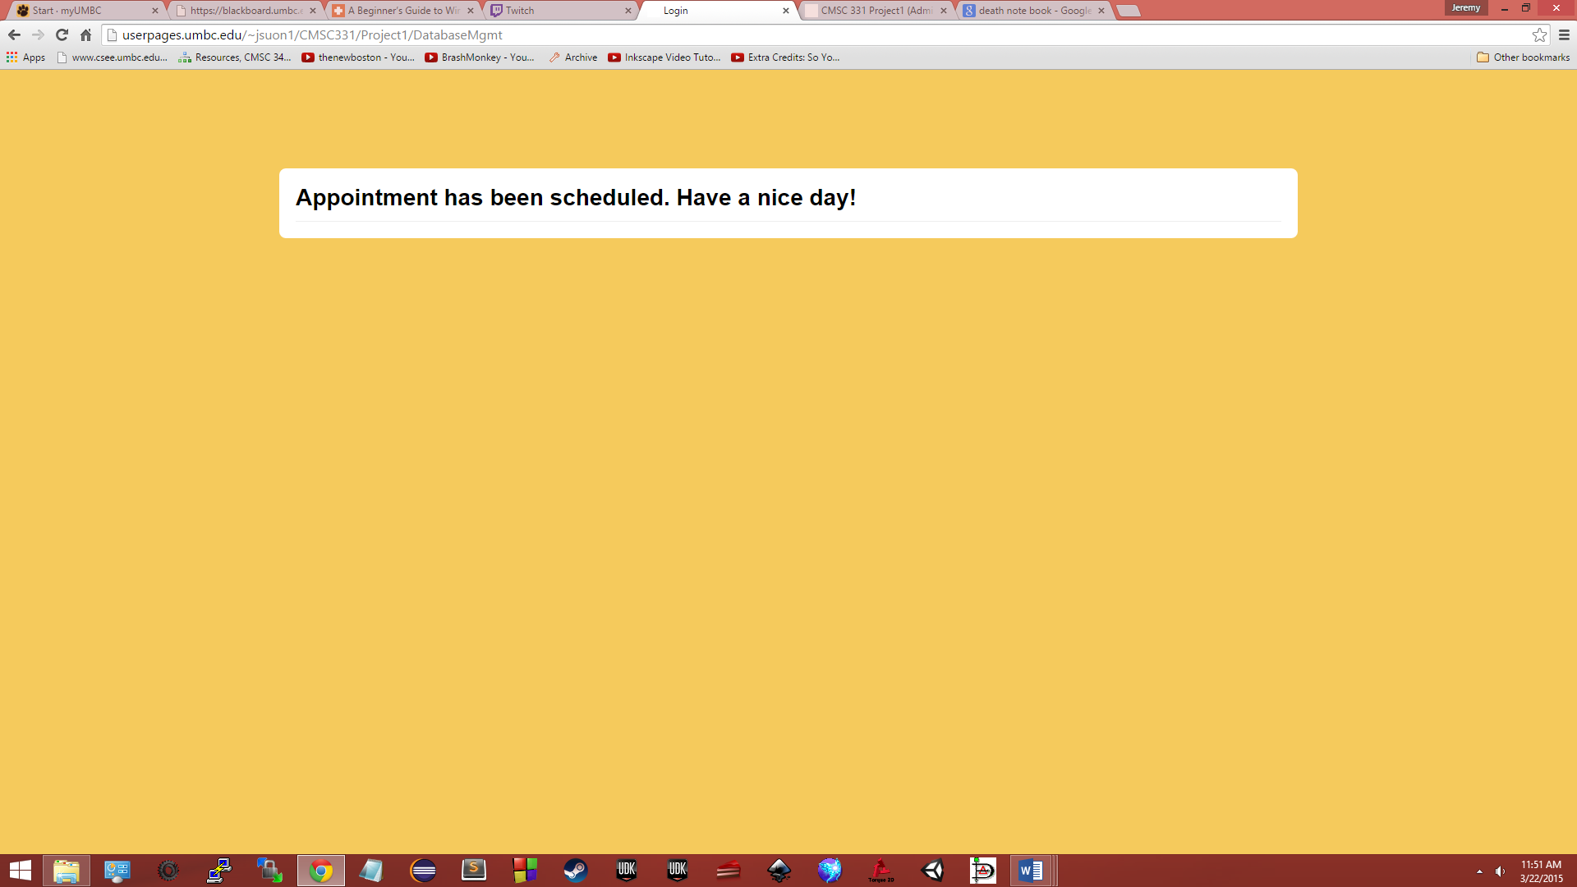

* + After the appointment has been selected and submitted, the student is then directed to an affirmation screen which allows the student to take note that his/her appointment has been scheduled and the process has been completed.

Code: The following pages are of code only.

Form.html

<!DOCTYPE html>

<html lang="en">

<head>

<meta charset="UTF-8" />

<title>Login</title>

<style type="text/css">

html{

background-color:

#f5ca5c;

font-family:

Arial;

font-size: 13px;

position: relative;

}

body{

margin: 0;

padding: 0;

}

a{

color: #07f;

text-decoration: none;

}

a:hover{

text-decoration: underline;

}

#login{

color: #000;

background-color: #fff;

margin: 120px auto 0;

padding: 20px 20px 20px;

position: relative;

width: 280px;

-webkit-border-radius: 8px;

-moz-border-radius: 8px;

border-radius: 8px;

}

h1{

font-family: "Helvetica Neue", Arial, Helvetica, sans-serif;

font-size: 28px;

line-height: 32px;

margin: 0;

padding: 0;

}

ul{

margin: 8px 20px;

padding: 0;

}

li{

margin-top: 8px;

}

input[type="text"],input[type="password"], textarea {

background-color: #F6F6F6;

border: 1px solid #999;

color: #444;

font-family: Arial, Helvetica, sans-serif;

font-size: 20px;

line-height: 16px;

padding: 4px;

-moz-border-radius: 4px;

-webkit-border-radius: 4px;

width: 262px;

}

.button {

background-color: #768089;

border: none;

color: #fff;

cursor: pointer;

display: inline-block;

font-size: 11px;

font-weight: bold;

height: 25px;

overflow: visible;

padding: 0 12px;

margin: 0;

text-decoration: none;

vertical-align: top;

white-space: nowrap;

width: auto;

-moz-appearance: none;

-moz-border-radius: 4px;

-webkit-appearance: none;

-webkit-border-radius: 4px;

line-height: 25px;

}

.button:hover {

background-color: #87929D;

color: #fff;

text-decoration: none;

}

a.button.large {

line-height: 32px;

}

.button.large {

font-size: 16px;

height: 32px;

padding: 0 16px;

}

.button.go {

background-color: #66AA44;

color: #FFF;

}

.button.go:hover {

background-color: #70B74E;

color: #FFF;

}

.button.stop {

background-color: #CC4444;

color: #FFF;

}

.button.stop:hover {

background-color: #d55;

}

input[type="password"]{

font-weight: bold;

letter-spacing:3px

}

.field{

margin: 8px 0;

}

.field label{

display: block;

font-weight: bold;

font-size: 14px;

}

.actions{

text-align: right;

}

.bottom{

border-top: 0px solid #ddd;

padding-top: 12px;

font-size: 11px;

color: #666;

}

.top{

border-bottom: 1px solid #eee;

padding-bottom: 12px;

}

.actions{

overflow: hidden;

}

.actions .secondary{

float: left;

font-size: 14px;

line-height: 32px;

text-align: left;

}

.create-account{

padding: 12px 0;

border-top: 0px solid #ddd;

margin-top: 0px;

}

.logout-warning{

color: #CC4444;

font-size: 14px;

font-weight: bold;

padding-top: 12px;

}

.logout-warning .first{

font-size: 12px;

}

.logout-warning .second{

font-size: 16px;

}

p{

margin: 0;

padding: 0;

}

.login-create{

font-size: 16px;

font-weight: normal;

}

.button-item{

line-height: 32px;

margin: 8px 0px 12px;

}

.button-item .button{

margin-right: 4px;

width: 70px;

padding: 0 8px;

text-align: center;

}

@media screen and (max-width: 767px){

html, body { background-color: #fff; }

#login { border-radius: 0; margin: 60px 0 0; width: 94%; padding: 3%; border-top: 1px solid #ddd; }

input[type="text"],input[type="password"], textarea { width: 96%; padding: 2% 2%; }

.button-item { margin: 8px 8px 12px; }

}

</style>

</head

>

<body>

<div id="login" >

<div id="form">

<div class="top">

<form action="LoginOptions.php" method="post" name="upass">

<h1>Log In<span class="login-create"> or <a href="http://accounts.umbc.edu/">Create an Account</a></span></h1>

<div class="field">

<label for="username">Username</label>

<input id="username" size="20" maxlength="255" type="text" name="name">

</div>

<div class="field">

<label for="password">Password</label>

<input id="password" size="20" maxlength="255" type="password" name="password">

</div>

<div class="field">

<label for="id">Student ID</label>

<input id="id" size="20" maxlength="255" type="text" name="id">

</div>

<div class="field">

<label for="major">Major</label>

<input id="major" size="20" maxlength="255" type="text" name="major">

</div>

<div class="actions">

<div class="secondary">

<div><a href="https://webadmin.umbc.edu/admin/Security/PasswordAssistance">Forgot your password?</a></div>

</div>

<div class="primary">

<input value="Log In" class="button go large" type="submit" name="send">

</div>

</div>

</form>

</body>

</html>

LoginOptions.php

<!DOCTYPE html>

<html lang="en">

<head>

<meta charset="UTF-8" />

<title>Login</title>

<style type="text/css">

html{

background-color: #f5ca5c;

font-family: Arial;

font-size: 13px;

position: relative;

}

body{

margin: 0;

padding: 0;

}

a{

color: #07f;

text-decoration: none;

}

a:hover{

text-decoration: underline;

}

#login{

color: #000;

background-color: #fff;

margin: 120px auto 0;

padding: 20px 20px 20px;

position: relative;

width: 1200px;

-webkit-border-radius: 8px;

-moz-border-radius: 8px;

border-radius: 8px;

}

h1{

font-family: "Helvetica Neue", Arial, Helvetica, sans-serif;

font-size: 28px;

line-height: 32px;

margin: 0;

padding: 0;

}

ul{

margin: 8px 20px;

padding: 0;

}

li{

margin-top: 8px;

}

.button {

background-color: #768089;

border: none;

color: #fff;

cursor: pointer;

display: inline-block;

font-size: 11px;

font-weight: bold;

height: 25px;

overflow: visible;

padding: 0 12px;

margin: 0;

text-decoration: none;

vertical-align: top;

white-space: nowrap;

width: auto;

-moz-appearance: none;

-moz-border-radius: 4px;

-webkit-appearance: none;

-webkit-border-radius: 4px;

line-height: 25px;

}

.button:hover {

background-color: #87929D;

color: #fff;

text-decoration: none;

}

a.button.large {

line-height: 32px;

}

.button.large {

font-size: 16px;

height: 32px;

padding: 0 16px;

}

.button.go {

background-color: #66AA44;

color: #FFF;

}

.button.go:hover {

background-color: #70B74E;

color: #FFF;

}

.button.stop {

background-color: #CC4444;

color: #FFF;

}

.button.stop:hover {

background-color: #d55;

}

.field{

margin: 8px 0;

}

.field label{

display: block;

font-weight: bold;

font-size: 14px;

}

.actions{

text-align: right;

}

.bottom{

border-top: 0px solid #ddd;

padding-top: 12px;

font-size: 11px;

color: #666;

}

.top{

border-bottom: 1px solid #eee;

padding-bottom: 12px;

}

.actions{

overflow: hidden;

}

.actions .secondary{

float: left;

font-size: 14px;

line-height: 32px;

text-align: left;

}

p{

margin: 0;

padding: 0;

}

.button-item{

line-height: 32px;

margin: 8px 0px 12px;

}

.button-item .button{

margin-right: 4px;

width: 70px;

padding: 0 8px;

text-align: center;

}

@media screen and (max-width: 767px){

html, body { background-color: #fff; }

#login { border-radius: 0; margin: 60px 0 0; width: 94%; padding: 3%; border-top: 1px solid #ddd; }

input[type="text"],input[type="password"], textarea { width: 96%; padding: 2% 2%; }

.button-item { margin: 8px 8px 12px; }

}

</style>

</head>

<body>

<div id="login" >

<div id="form">

<div class="top">

<h1>Please select from the following: </h1>

<?php

$Username = $_POST['name'];

$Password = $_POST['password'];

$ID = $_POST['id'];

$Major = $_POST['major'];

echo("<h2>Student Username: $Username </h2>");

echo("<form action=\"Appointments.php\" method=\"post\" name=\"upass\">");

echo("<b>Date: </b>");

echo("<select name=\"date\">");

echo("<option value=\"Monday\">Monday</option>");

echo("<option value=\"Tuesday\">Tuesday</option>");

echo("<option value=\"Wednesday\">Wednesday</option>");

echo("<option value=\"Thursday\">Thursday</option>");

echo("<option value=\"Friday\">Friday</option>");

echo("</select>");

echo("<h3>Group Advising</h3>");

echo("<input type=\"radio\" name=\"counselor\" value=\"Group 1 Advising\">Group 1 Advising<br>");

echo("<input type=\"radio\" name=\"counselor\" value=\"Group 2 Advising\">Group 2 Advising<br>");

echo("<input type=\"radio\" name=\"counselor\" value=\"Group 3 Advising\">Group 3 Advising<br>");

echo("<input type=\"radio\" name=\"counselor\" value=\"Group 4 Advising\">Group 4 Advising<br>");

echo("<input type=\"radio\" name=\"counselor\" value=\"Group 5 Advising\">Group 5 Advising<br><br>");

echo("<h3>Individual Advising</h3>");

echo("<input type=\"radio\" name=\"counselor\" value=\"Josh Abrams\">Josh Abrams<br>");

echo("<input type=\"radio\" name=\"counselor\" value=\"Anne Arey\">Anne Arey<br>");

echo("<input type=\"radio\" name=\"counselor\" value=\"Emily Stephens\">Emily Stephens<br>");

echo("<input type=\"radio\" name=\"counselor\" value=\"Snoop Dogg\">Snoop Dogg<br>");

echo("<input type=\"radio\" name=\"counselor\" value=\"Richard Fizzle\">Richard Fizzle<br>");

echo("<input type=\"radio\" name=\"counselor\" value=\"Johnathon Drizzle\">Johnathon Drizzle<br>");

echo("<input type=\"radio\" name=\"counselor\" value=\"Henry Chizzle\">Henry Chizzle<br><br>");

echo("<input type=\"hidden\" name=\"user\" value=\"$Username\">");

echo("<input type=\"hidden\" name=\"id\" value=\"$ID\">");

echo("<input type=\"hidden\" name=\"major\" value=\"$Major\">");

echo("<input type=\"submit\" class=\"button go large\" name=\"send\" value=\"Submit\"><br>");

echo("</form>");

?>

</body>

</html>

Appointments.html

<!DOCTYPE html>

<html lang="en">

<head>

<meta charset="UTF-8" />

<title>Login</title>

<style type="text/css">

html{

background-color: #f5ca5c;

font-family: Arial;

font-size: 13px;

position: relative;

}

body{

margin: 0;

padding: 0;

}

a{

color: #07f;

text-decoration: none;

}

a:hover{

text-decoration: underline;

}

#login{

color: #000;

background-color: #fff;

margin: 120px auto 0;

padding: 20px 20px 20px;

position: relative;

width: 1200px;

-webkit-border-radius: 8px;

-moz-border-radius: 8px;

border-radius: 8px;

}

h1{

font-family: "Helvetica Neue", Arial, Helvetica, sans-serif;

font-size: 28px;

line-height: 32px;

margin: 0;

padding: 0;

}

ul{

margin: 8px 20px;

padding: 0;

}

li{

margin-top: 8px;

}

.button {

background-color: #768089;

border: none;

color: #fff;

cursor: pointer;

display: inline-block;

font-size: 11px;

font-weight: bold;

height: 25px;

overflow: visible;

padding: 0 12px;

margin: 0;

text-decoration: none;

vertical-align: top;

white-space: nowrap;

width: auto;

-moz-appearance: none;

-moz-border-radius: 4px;

-webkit-appearance: none;

-webkit-border-radius: 4px;

line-height: 25px;

}

.button:hover {

background-color: #87929D;

color: #fff;

text-decoration: none;

}

a.button.l

-height: 32px;

}

.button.large {

font-size: 16px;

height: 32px;

padding: 0 16px;

}

.button.go {

background-color: #66AA44;

color: #FFF;

}

.button.go:hover {

background-color: #70B74E;

color: #FFF;

}

.button.stop {

background-color: #CC4444;

color: #FFF;

}

.button.stop:hover {

background-color: #d55;

}

.field{

margin: 8px 0;

}

.field label{

display: block;

font-weight: bold;

font-size: 14px;

}

.actions{

text-align: right;

}

.bottom{

border-top: 0px solid #ddd;

padding-top: 12px;

font-size: 11px;

color: #666;

}

.top{

border-bottom: 1px solid #eee;

padding-bottom: 12px;

}

.actions{

overflow: hidden;

}

.actions .secondary{

float: left;

font-size: 14px;

line-height: 32px;

text-align: left;

}

p{

margin: 0;

padding: 0;

}

.button-item{

line-height: 32px;

margin: 8px 0px 12px;

}

.button-item .button{

margin-right: 4px;

width: 70px;

padding: 0 8px;

text-align: center;

}

@media screen and (max-width: 767px){

html, bodyq { background-color: #fff; }

#login { border-radius: 0; margin: 60px 0 0; width: 94%; padding: 3%; border-top: 1px solid #ddd; }

input[type="text"],input[type="password"], textarea { width: 96%; padding: 2% 2%; }

.button-item { margin: 8px 8px 12px; }

}

</style>

</head>

<body>

<div id="login" >

<div id="form">

<div class="top">

<?php

$Advisor = $_POST['counselor'];

$user = $_POST['user'];

$id = $_POST['id'];

$major = $_POST['major'];

$date = $_POST['date'];

echo("<h1>Available Appointments for $Advisor on $date:</h1>");

echo("<br>");

include('CommonMethods.php');

$debug = false;

$Common = new CommonMethods($debug);

$sql = "SELECT `9:00-9:30`, `9:30-10:00`, `10:00-10:30`, `10:30-11:00`, `11:00-11:30`,

`11:30-12:00`, `12:00-12:30`, `12:30-1:00`, `1:00-1:30`, `1:30-2:00`, `2:00-2:30`,

`2:30-3:00`, `3:00-3:30`, `3:30-4:00`

FROM `$date Advising Appointments`

WHERE `Name` = '$Advisor'";

$rs = $Common->executeQuery($sql, "Advising Appointments");

$count = 0;

$appts = array("9:00-9:30", "9:30-10:00", "10:00-10:30", "10:30-11:00", "11:00-11:30", "11:30-12:00",

"12:00-12:30", "12:30-1:00", "1:00-1:30", "1:30-2:00", "2:00-2:30", "2:30-3:00",

"3:00-3:30", "3:30-4:00");

while($row = mysql_fetch_row($rs)){

echo("<form action=\"DatabaseMgmt\" method=\"post\" name=\"upass\">");

foreach($row as $element){

if(strpos($Advisor, 'Advising') > 0){

if(str_word_count($element) == 10)

echo("<b>Not Available<b><br>");

else{

echo("<input type=\"radio\" name=\"appt\" value=\"$appts[$count]\">");

echo("<b>$appts[$count]: " . str_word_count($element) . " student(s) currently in group</b><br>");

}

}

else{

if($element != '0')

echo("<b>Not Available<b><br>");

else

echo("<input type=\"radio\" name=\"appt\" value=\"$appts[$count]\"><b>$appts[$count]</b><br>");

}

$count = $count + 1;

}

echo("<input type=\"hidden\" name=\"date\" value=\"$date\">");

echo("<input type=\"hidden\" name=\"user\" value=\"$user\">");

echo("<input type=\"hidden\" name=\"id\" value=\"$id\">");

echo("<input type=\"hidden\" name=\"major\" value=\"$major\">");

echo("<input type=\"hidden\" name=\"Advisor\" value=\"$Advisor\">");

}

echo("<br><input type=\"submit\" class=\"button go large\" name=\"send\" value=\"Submit\"><br>");

echo("</form>");

?>

</body>

</html>

DatabaseMgmt.php

<!DOCTYPE html>

<html lang="en">

<head>

<meta charset="UTF-8" />

<title>Login</title>

<style type="text/css">

html{

background-color: #f5ca5c;

font-family: Arial;

font-size: 13px;

position: relative;

}

body{

margin: 0;

padding: 0;

}

a{

color: #07f;

text-decoration: none;

}

a:hover{

text-decoration: underline;

}

#login{

color: #000;

background-color: #fff;

margin: 120px auto 0;

padding: 20px 20px 20px;

position: relative;

width: 1200px;

-webkit-border-radius: 8px;

-moz-border-radius: 8px;

border-radius: 8px;

}

h1{

font-family: "Helvetica Neue", Arial, Helvetica, sans-serif;

font-size: 28px;

line-height: 32px;

margin: 0;

padding: 0;

}

ul{

margin: 8px 20px;

padding: 0;

}

li{

margin-top: 8px;

}

.button {

background-color: #768089;

border: none;

color: #fff;

cursor: pointer;

display: inline-block;

font-size: 11px;

font-weight: bold;

height: 25px;

overflow: visible;

padding: 0 12px;

margin: 0;

text-decoration: none;

vertical-align: top;

white-space: nowrap;

width: auto;

-moz-appearance: none;

-moz-border-radius: 4px;

-webkit-appearance: none;

-webkit-border-radius: 4px;

line-height: 25px;

}

.button:hover {

background-color: #87929D;

color: #fff;

text-decoration: none;

}

a.button.large {

line-height: 32px;

}

.button.large {

font-size: 16px;

height: 32px;

padding: 0 16px;

}

.button.go {

background-color: #66AA44;

color: #FFF;

}

.button.go:hover {

background-color: #70B74E;

color: #FFF;

}

.button.stop {

background-color: #CC4444;

color: #FFF;

}

.button.stop:hover {

background-color: #d55;

}

.field{

margin: 8px 0;

}

.field label{

display: block;

font-weight: bold;

font-size: 14px;

}

.actions{

text-align: right;

}

.bottom{

border-top: 0px solid #ddd;

padding-top: 12px;

font-size: 11px;

color: #666;

}

.top{

border-bottom: 1px solid #eee;

padding-bottom: 12px;

}

.actions{

overflow: hidden;

}

.actions .secondary{

float: left;

font-size: 14px;

line-height: 32px;

text-align: left;

}

p{

margin: 0;

padding: 0;

}

.button-item{

line-height: 32px;

margin: 8px 0px 12px;

}

.button-item .button{

margin-right: 4px;

width: 70px;

padding: 0 8px;

text-align: center;

}

@media screen and (max-width: 767px){

html, bodyq { background-color: #fff; }

#login { border-radius: 0; margin: 60px 0 0; width: 94%; padding: 3%; border-top: 1px solid #ddd; }

input[type="text"],input[type="password"], textarea { width: 96%; padding: 2% 2%; }

.button-item { margin: 8px 8px 12px; }

}

</style>

</head>

<body>

<div id="login" >

<div id="form">

<div class="top">

<?php

$Advisor = $_POST['Advisor'];

$Appt = $_POST['appt'];

$User = $_POST['user'];

$ID = $_POST['id'];

$Major = $_POST['major'];

$Date = $_POST['date'];

$Group;

echo("<h1>Appointment has been scheduled. Have a nice day!</h1>");

include('CommonMethods.php');

$debug = false;

$Common = new CommonMethods($debug);

if(strpos($Advisor, "Advising") > 0){

$sql = "SELECT `$Appt` FROM `$Date Advising Appointments` WHERE `Name` = '$Advisor'";

$rs = $Common->executeQuery($sql, "Advising Appointments");

$row = mysql_fetch_row($rs);

foreach($row as $element){

if($element != '0')

$Group = $Group . " " . $element;

}

$Group = substr($Group, 1);

$sql = "UPDATE `$Date Advising Appointments` SET `$Appt` = '$Group $User' WHERE `Name`= '$Advisor'";

$rs = $Common->executeQuery($sql, "Advising Appointments");

}

else{

$sql = "UPDATE `$Date Advising Appointments` SET `$Appt` = '$User' WHERE `Name`= '$Advisor'";

$rs = $Common->executeQuery($sql, "Advising Appointments");

}

$sql = "INSERT INTO `Student`(`User`, `ID`, `Major`) VALUES ('$User', '$ID', '$Major')";

$rs = $Common->executeQuery($sql, "Advising Appointments");

?>

</body>

</html>

CommonMethods.php

<?php

class CommonMethods{

var $conn;

var $debug;

function CommonMethods($debug){

$this->debug = $debug;

$result = $this->connect("jsuon1");

return $result;

}

function connect($database){

$conn = mysql_connect("studentdb.gl.umbc.edu", "jsuon1", "jsuon1")

or die("Could not connect to MySQL" . mysql_eror());

$result = mysql_select_db($database, $conn)

or die("Could not select $database database");

$this->conn = $conn;

}

function executeQuery($query, $filename){

if($this->debug == true)

echo("$query <br/>\n");

$result = mysql_query($query, $this->conn)

or die("Could not execute query " . $query . " in " . $filename);

return $result;

}

}

?>